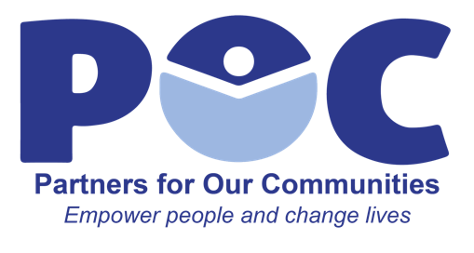
Talent Manager of Volunteer Workforce
The Talent Manager of Volunteer Workforce will oversee all aspects of the organizations volunteer program including recruiting, training, and supervising volunteers.
Skills/Qualifications
- Experience in volunteering and recruitment
- Excellent communication and interpersonal skills
- Excellent organization and team-building skills
- Ability to work well with a diverse group of staff and volunteers
- Ability to work productively in an unstructured environment with frequent interruptions
- Excellent verbal and written communication skills
- Excellent organizational skills and attention to detail
- Strong leadership skills with ability to motivate and encourage others
- Passion for developing employees
- Deep understanding of and passion for the issues facing POC clients
Essential Job Duties
- Communicate with all departments of the organization to identify available opportunities and needs for volunteers
- Recruit volunteer staff to fit these roles using a variety of resources and techniques
- Place volunteers in different roles based on their qualifications
- Gather information about each volunteer’s skills, availability, and goals; matches volunteers with opportunities that optimize their contributions as well as development of the volunteers
- Utilize relationships and connections with community partners to identify future placement opportunities for volunteers in line with their goals
- Ensure volunteers understand their responsibilities and receive the proper training
- Schedule, coordinate, and assign volunteers to appropriate departments, supervisors, and/or mentors
- Regularly communicate with volunteers to ensure placement is a good fit for individual’s skills and goals
- Perform periodic evaluations of volunteers; manage performance of volunteer staff and provide constructive feedback
- Mentor high potential volunteers and work with them to identify potential career paths
- Maintain files, records, applications, and other data concerning volunteer program
- Draft, maintain, and publish guidelines, best practices, and procedures for volunteer program
- Coordinate volunteer recognition and appreciation events and activities
- Keep pulse of community and clients and cultivate strong relationships within community
- Organize training and lead on-the-job training
- Identify professional development opportunities for volunteer staff
- Ensure volunteers are satisfied by creating a health working environment
- Evaluate all aspects of volunteer programs to ensure effectiveness and to recommend/implement changes as appropriate
- Provide ongoing support and guidance for volunteers
- Act as a single point of contact for communications with volunteers
- Confer with volunteers to resolve grievances and promote cooperation and interest
- Provide quality volunteer experience that will enhance reputation of POC in community

