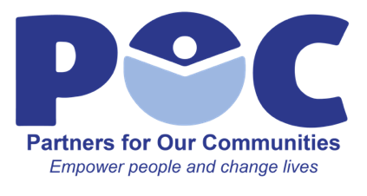

Leadership & Immigration Program Manager
Reporting to the Executive Director of POC, the Leadership & Immigration Program Manager will have responsibility for programs and grants related to immigration and housing eviction prevention as well as programs related to ROLE Women’s Leadership.
Skills/Qualifications
- A Master’s degree in related field or its equivalent
- Ability to work effectively in collaboration with diverse groups of people
- Outstanding written and oral communication skills and ability to work well with staff and the community
- Solid organizational abilities, including planning, delegating, program development and task facilitation
- Strong public speaking ability
- Ability to create welcoming spaces for members of the community – regardless of immigration status
- Deep understanding of and passion about the issues facing immigrant communities
- Possess demonstrated skill of conflict resolution and ability to perceive and identify potential challenges or roadblocks to successful execution of programs
- Possess seasoned understanding of immigration law and key features of immigration status and adjustment processes, including points of intervention and advocacy on local, state, and federal levels
- Ability to juggle multiple streams of work, prioritize, and problem solve in complex and nuanced situations
- Comfort operating in complex and fluid environments, responding innovatively and rapidly to emerging opportunities or concerns
- An exceptional team player; exemplifies a work style that is flexible, respectful, collaborative and nimble
- Ability to build strong relationships and trust across race, gender, class, and other group identities, both internally and externally
- Strong English and Spanish language skills

Essential Job Duties
- Access to Justice and Housing Outreach Eviction Prevention Grant Coordinator
- Maintain accurate records, data, and statistics
- Provide programmatic grant stats, monthly reports, and quarterly narrative reports
- Recruit, select, train, and manage performance of community navigators
- Support community navigators’ presentations and outreach efforts
- Manage social media and outreach efforts for programs
- Supervise Illinois Welcome Center case managers for POC North and South
  - Meet regularly with case managers to review cases
  - Provide expertise and assistance on difficult cases
  - Serve as central intake for cases received through social media
  - Provide direct service to clients; conduct consultations to determinate eligibility and assist clients with completing appropriate immigration forms and applications
  - Provide training and share knowledge of current immigration and housing policy updates
  - Manage IWC data and monthly reports

- ROLE Women’s Leadership Program Manager
  - Manage POC Sewing Studio, including all social media and outreach efforts
  - Engage with women in ROLE to keep pulse on community needs
  - Mentor and assist ROLE members on issues, including career development, immigration, housing, family counseling, and domestic problems
  - Facilitate opportunities for local artists, including organizing artist markets with community partners, artist fairs at POC, and social media outreach

- Serve as Site Director for POC South in Hanover Park
  - Create and implement innovative community outreach efforts to reach potential new clients
  - Manage all media and communications for POC South

- Serve as in-house expert on immigration, housing, and public benefits and disseminate knowledge to POC staff
  - Stay up to date on immigration law and regulations of the United States Citizenship and Immigration Services that impact our clients
  - Participate in professional development including attending workshops, trainings, conferences and in-service meetings and distribute important information to staff to ensure they remain up-to-date on immigration law

- Develop new and maintain current positive partnerships with community organizations and stakeholders and conduct outreach to community originations regarding immigration services and housing

- Assist with grant writing as needed including writing narrative sections for grants

