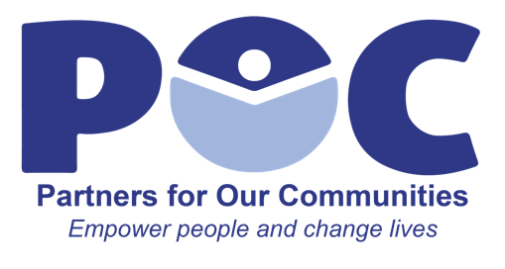

Reports to:
Rate: $20 per hour

Intake Coordinator
The Intake Coordinator efficiently documents client information and needs, referrals made to other agencies, and case outcomes.

Skills/Qualifications
- Deep knowledge and understanding of services and resources offered at POC
- Positive attitude and professional demeanor
- Ability to maintain confidentiality and use discretion when dealing with sensitive information
- Strong Spanish and English communication skills
- Excellent organizational skills
- Strong customer service acumen
- Flexibility to adapt to changing needs of organization, including working at different sites, outreach efforts

Essential Job Duties
- Works alongside the front desk receptionist at front entrance of POC building
- Identifies clients in need of comprehensive intake assessment
- Interviews client in private intake office and completes initial paperwork
- If client’s issues need to be escalated, directs clients to appropriate agency in the CRC or makes appointment for client with the Case Manager
- Creates and maintains client records in Charity Tracker
- Adds client information into Charity Tracker
- Answers phones and completes associated clerical tasks
- Maintains the building calendar for the agencies in the building
- Greets clients and visitors in a professional and welcoming manner as they enter the Community Resource Center
- Respond to client inquiries in polite and timely manner
- Contribute to team effort by accomplishing related tasks as needed

Employee Signature Date

